**All Eyes on Us**

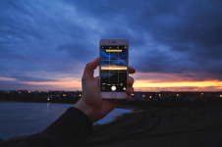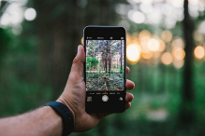

**Directions:** You will be creating a photojournalistic essay with 10 photos and captions that capture moments of connection to your local community, in your corner of the world. You will write an artist’s statement at the beginning of the essay to explain your project, its setting, and why you chose that part of your community.

You will use all five senses to help demonstrate your feelings towards your community, as well as to evoke feelings in the audience. Through your photos and storytelling abilities, you will allow the audience to glimpse into your world to establish a connection.

Your GOAL is that the audience will connect with what YOU are connected to in your own community, which will be evident in the photos you capture and the captions you write (ex: If basketball is something that you really connect with, how can you compose photos that would connect

an audience outside of your community to basketball and *why* basketball is important to you?)

**Brainstorming Questions:**

- What are the ‘positives’ in Hardee county?

- Where are moments of connection able to be made?

- What makes the USA home to you?

- Is there a cultural connection you’d like to share?

- How can people relate to your life on a global scale?

**Project Checklist:**

1. 10 photos that reflect your community ___________ 2. 10 captions that explain each photo ___________ 3. An artistic statement ___________ 4. Five senses demonstrated in your ___________ photos